

**What is Nmap?**

As we’ve said before, Nmap is a network scanner utility used for port mapping, host discovery and vulnerability scanning. Most of its functions are based on using IP packet analysis to detect and identify remote hosts, operating systems and services.

Nmap is used by large companies as well as smaller-sized organizations for port auditing, host monitoring, penetration testing and similar tasks.

Even with Nmap constantly being updated with new features since decades, its core function remains as a port scanner, helping users gather data by sending packets to local or remote ports. This is done by waiting for packet responses to determine if ports are closed, open or filtered.

The most popular method of using Nmap is via the terminal (command-line console), by performing a Nmap full scan command, but we’ll take a look into more examples below.

**How To Use Nmap**

Nmap is pretty easy to use if you’re familiar with command-line interfaces. As it’s already installed on most Linux/Unix-based distributions, you just have to execute the ‘nmap’ command from any terminal, and that’s it. It will display several options for you. Advanced users will also be able to use Nmap along with other system scripts and automated tasks in order to maximize the powers of this tool.

### How To Install Nmap on Linux, Windows and Mac

What happens if your operating system doesn’t include Nmap? No worries, let’s see how to install it. While the installation process can differ a bit depending on the OS you are using, in most cases (MacOS and Windows) our recommendation is to get the latest release from the [Nmap website’s download page](https://nmap.org/download.html).

**Installing Nmap on Linux**

Open the terminal and run the following commands to get Nmap installed:

* CentOS/Fedora: sudo dnf install nmap
* Ubuntu/Debian: sudo apt-get install nmap

That’s it. Nmap is now installed on Linux.

**Installing Nmap on Windows**

Once you download the installer, execute it and install it. The automated installer should take care of configuring Nmap for you in mere seconds.

**Installing Nmap on MacOS**

Mac users also have a full automated installer. Just run Nmap-mpkg file to begin the installation. After a few seconds, Nmap will be ready on your MacOS.

## TCP (Transmission Control Protocol)

## # Three Way Hand-Sake (TCP Protocol)

## 

Practical of three way handsake

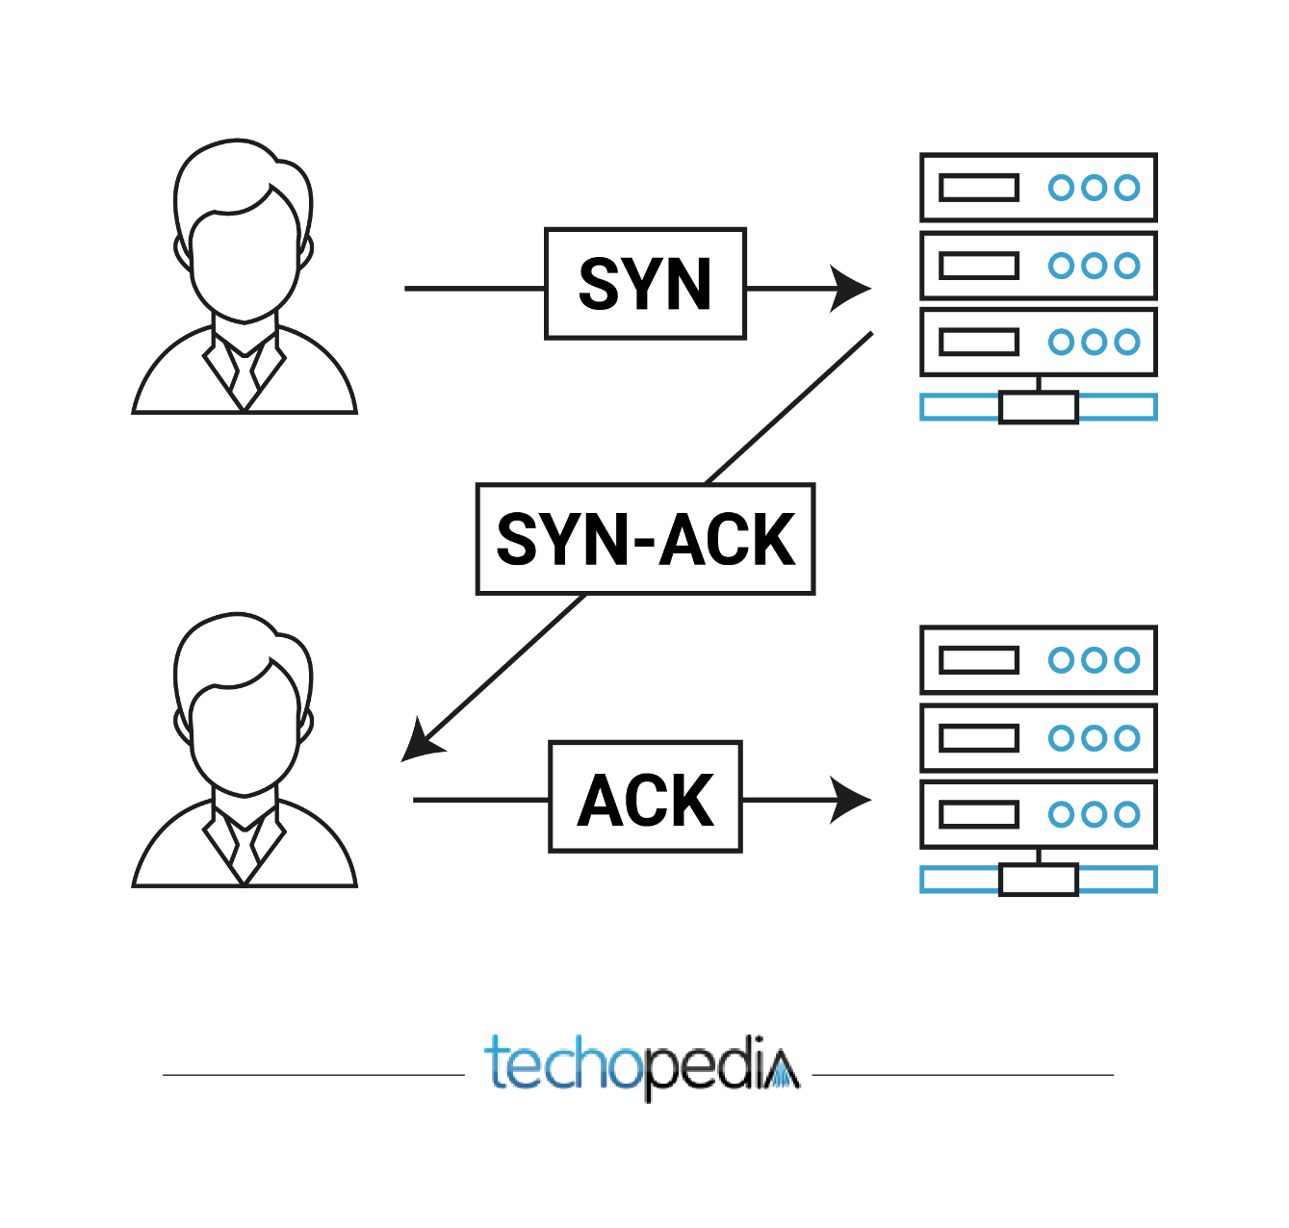

Working of TCP

To make sure that each message reaches its target location intact, the TCP/IP model breaks down the data into small bundles and afterward reassembles the bundles into the original message on the opposite end. Sending the information in little bundles of information makes it simpler to maintain efficiency as opposed to sending everything in one go.

After a particular message is broken down into bundles, these bundles may travel along multiple routes if one route is jammed but the destination remains the same.

For example, When a user requests a web page on the internet, somewhere in the world, the server processes that request and sends back an HTML Page to that user. The server makes use of a protocol called the HTTP Protocol. The HTTP then requests the TCP layer to set the required connection and send the HTML file.

Now, the TCP breaks the data into small packets and forwards it towards the Internet Protocol (IP) layer. The packets are then sent to the destination through different routes.

The TCP layer in the user’s system waits for the transmission to get finished and acknowledges once all packets have been received.

Offical website of Nmap (<https://nmap.org/>)

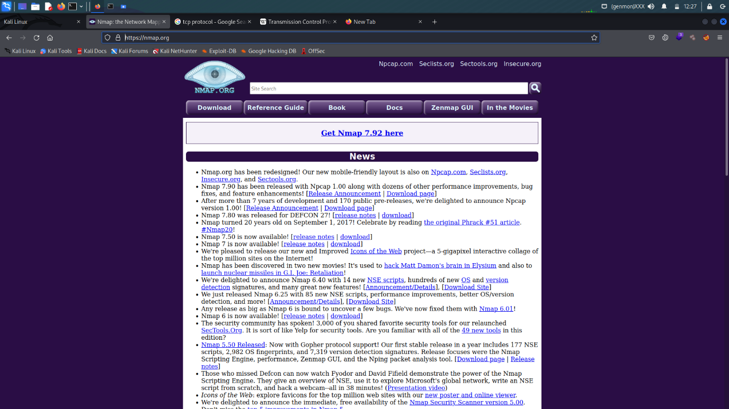

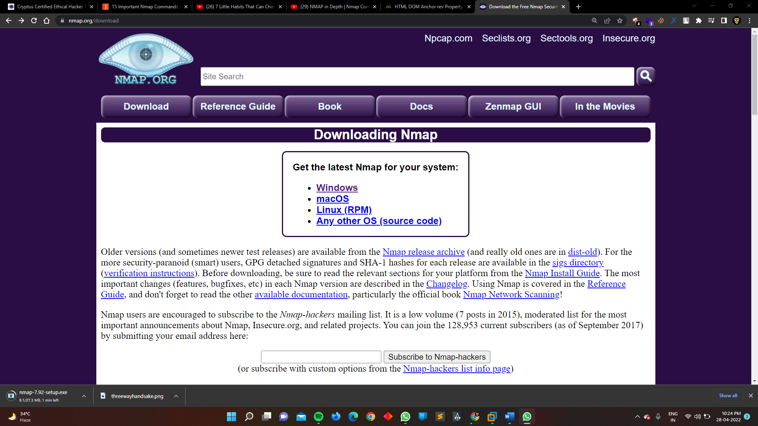

Downloads Nmap in windows :-

GUI is also avalable in Nmap ….

GUI Version of Nmap

Namp basic commands :-

Target scanning

Scan a single ip “nmap 192.168.20.128”

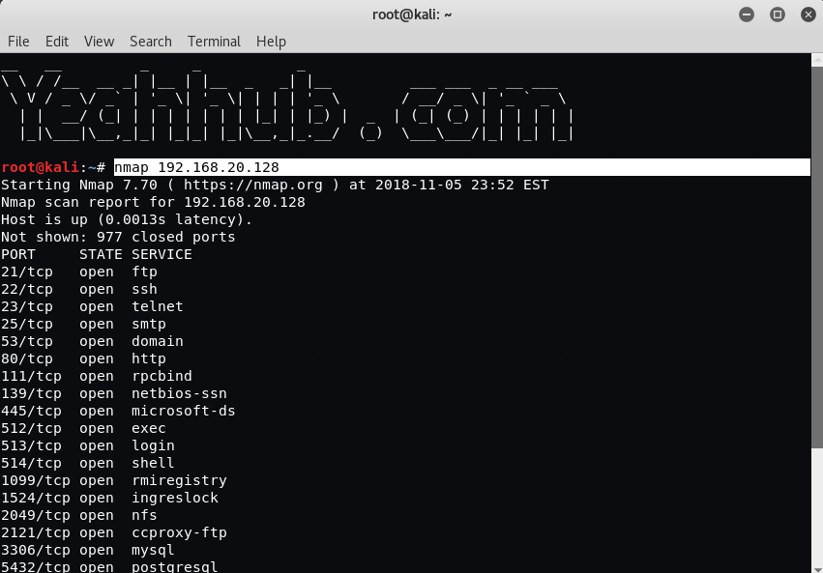

|  |  |
| --- | --- |
| Scan a host | nmap www.example.com |

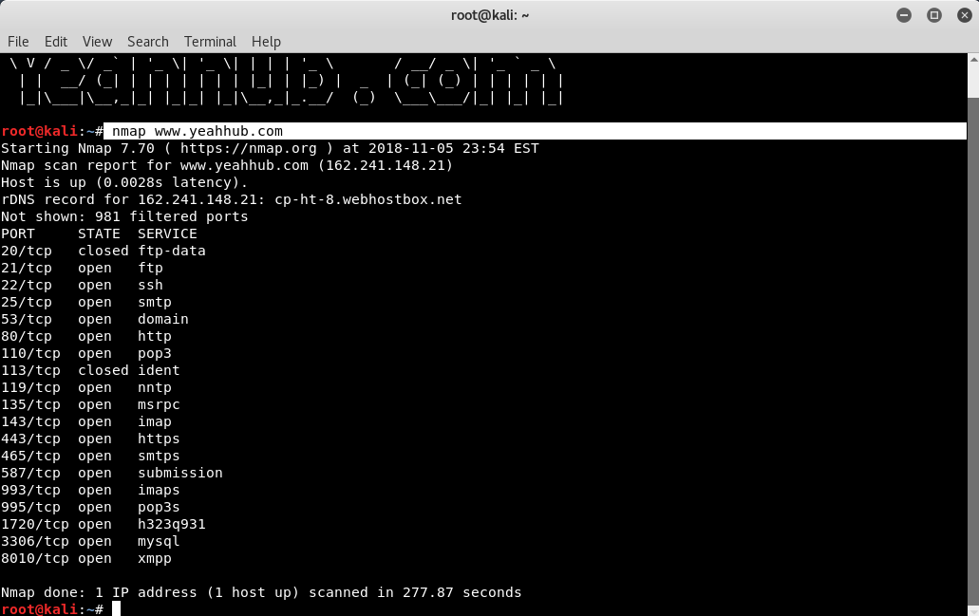

|  |  |
| --- | --- |
| Scan a range of IPs | nmap 192.168.20.120-128 |

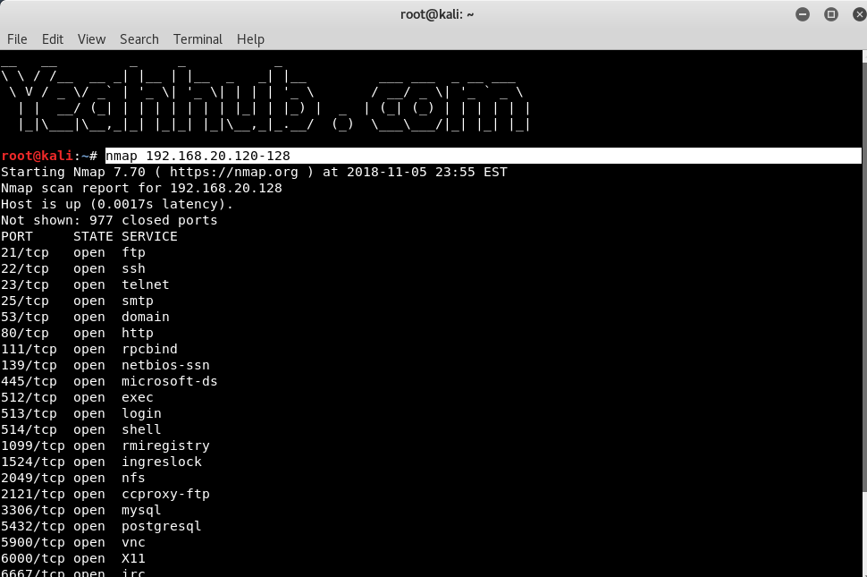

|  |  |
| --- | --- |
| Scan a subnet | nmap 192.168.20.2/24 |

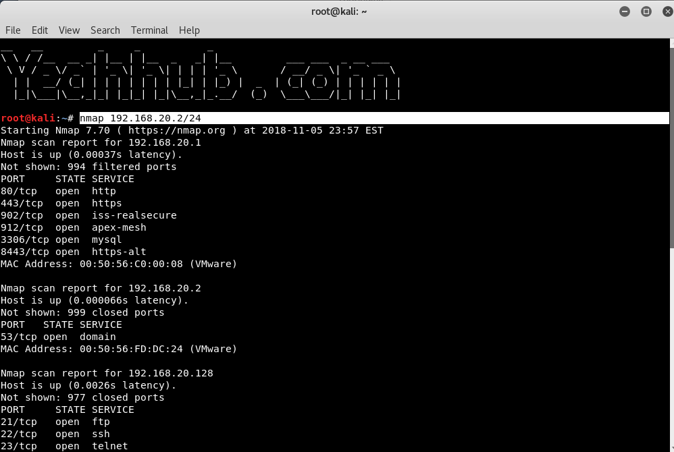

|  |  |
| --- | --- |
| Scan targets from Text file | nmap -iL ips.txt |

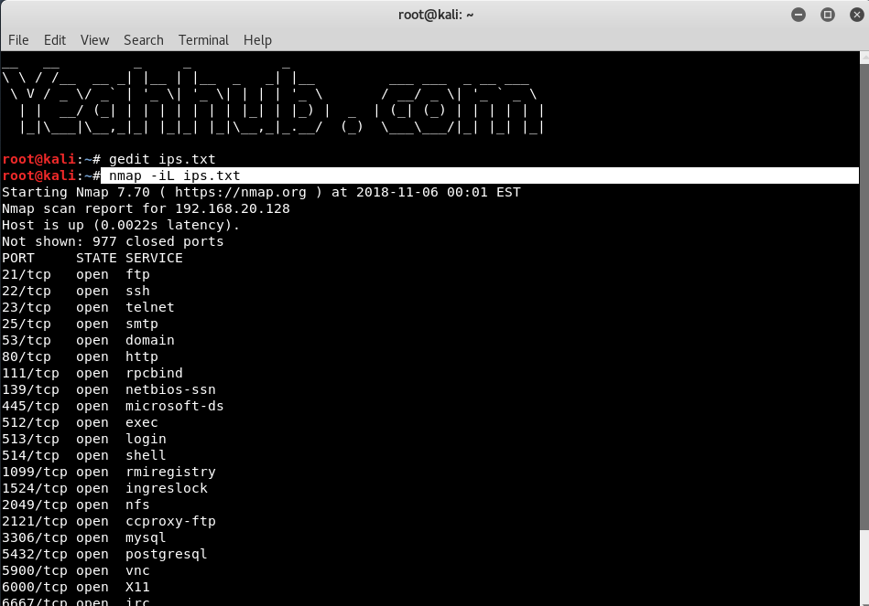

Port Selection

|  |  |
| --- | --- |
| Scan a single port | nmap -p 22 192.168.20.128 |

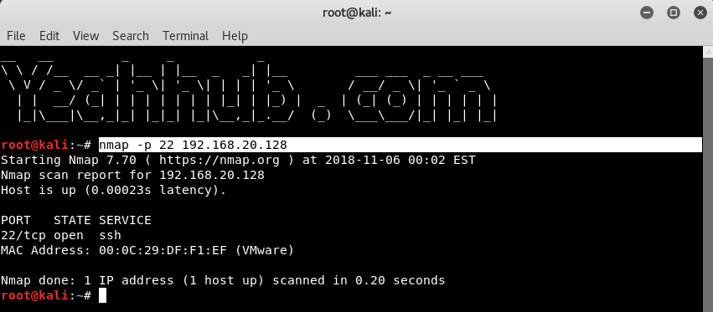

|  |  |
| --- | --- |
| Scan a range of ports | nmap -p 1-100 192.168.20.128 |

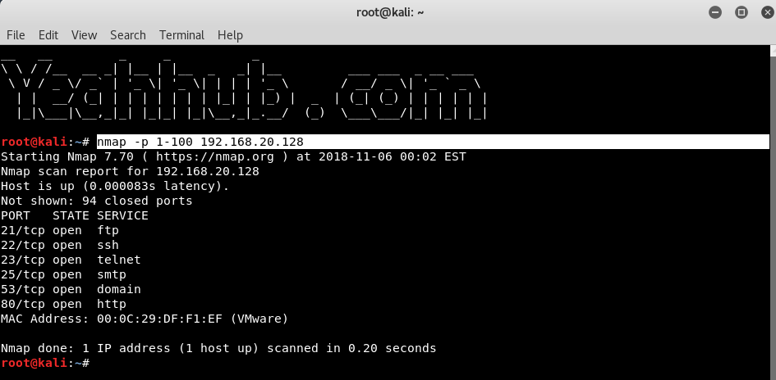

|  |  |
| --- | --- |
| Scan 100 common ports | nmap -F 192.168.20.128 |

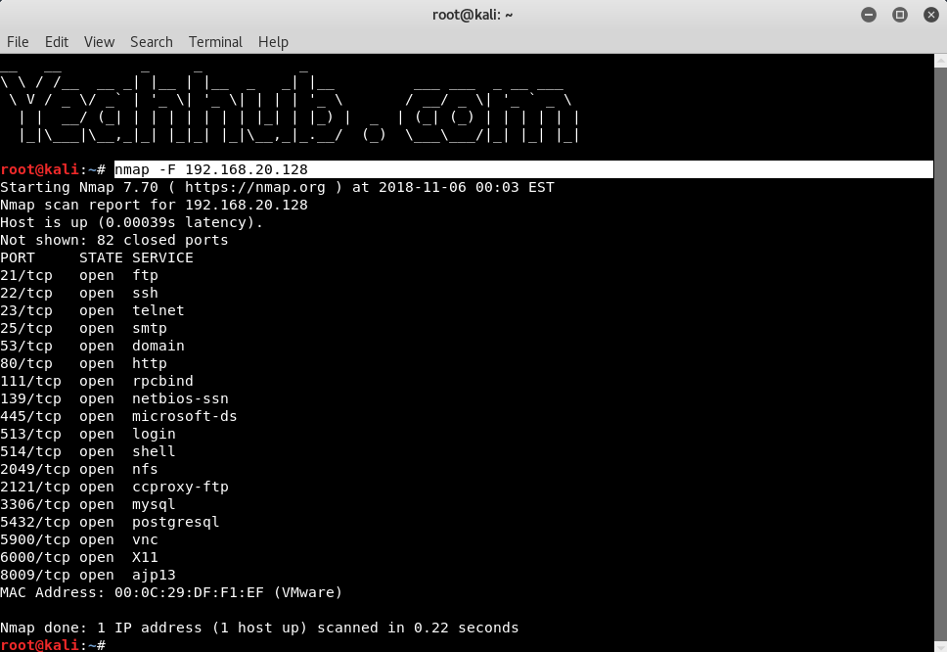

|  |  |
| --- | --- |
| Scan all ports | nmap -p- 192.168.20.128 |

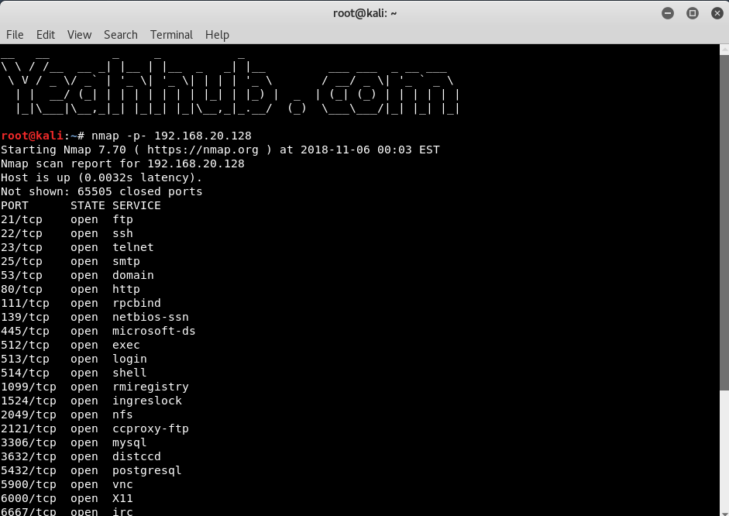

|  |  |
| --- | --- |
| Specify UDP or TCP scan | nmap -p U:137,T:139 192.168.20.128 |

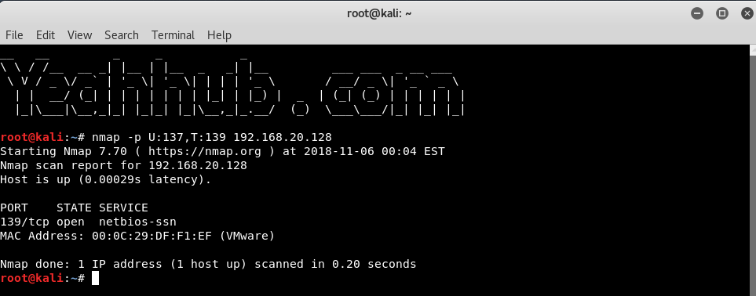

**Scan Types**

|  |  |
| --- | --- |
| Scan using TCP connect | nmap -sT 192.168.20.128 |

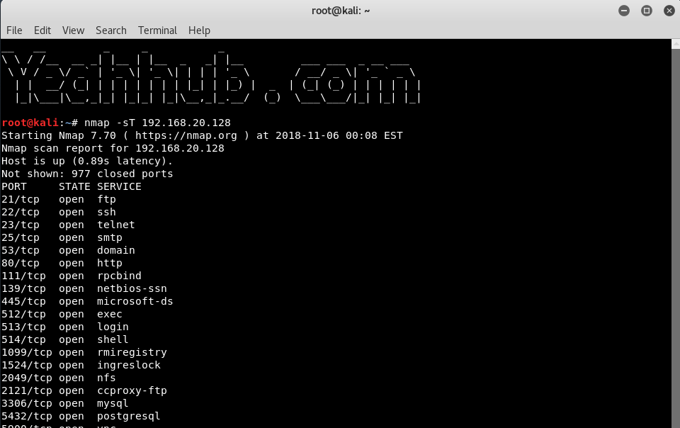

|  |  |
| --- | --- |
| Scan using TCP SYN scan | nmap -sS 192.168.20.128 |

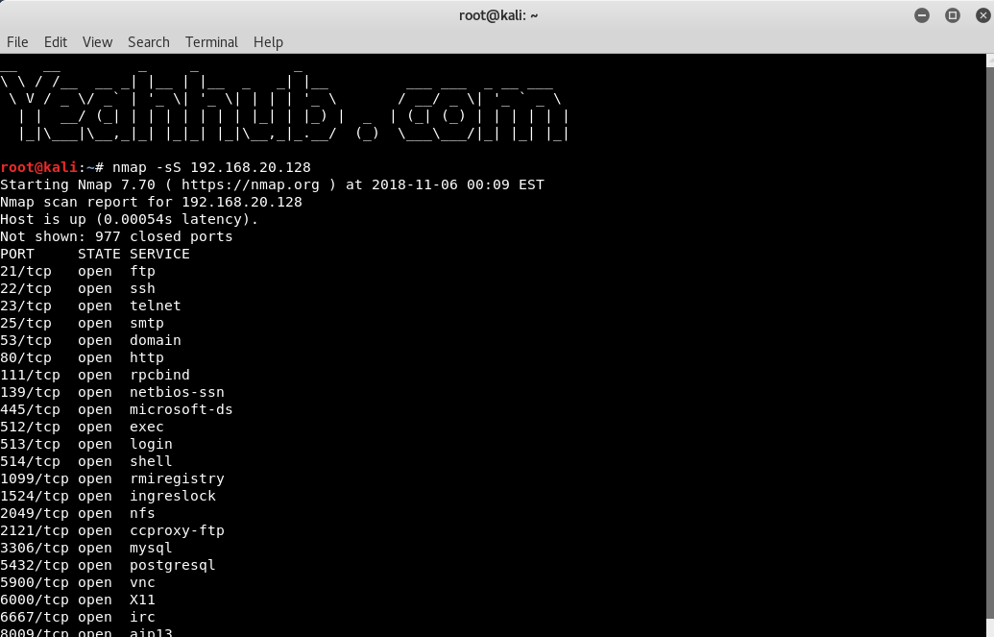

|  |  |
| --- | --- |
| Scan UDP ports | nmap -sU -p 123,161,162 192.168.20.128 |

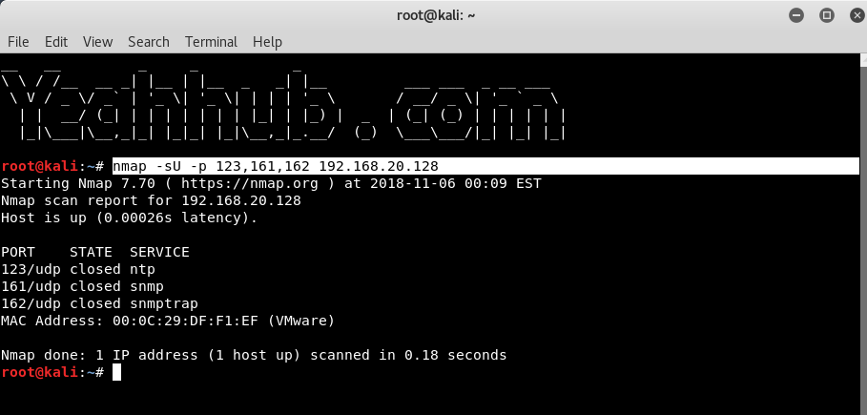

|  |  |
| --- | --- |
| Scan Selected ports (Ignore Discovery) | nmap -Pn -F 192.168.20.128 |

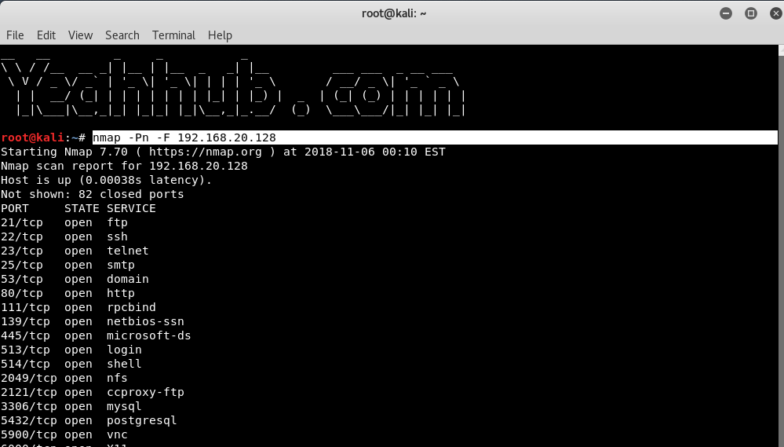

**Service and OS Detection**

|  |  |
| --- | --- |
| Detect OS and Services | nmap -A 192.168.20.128 |

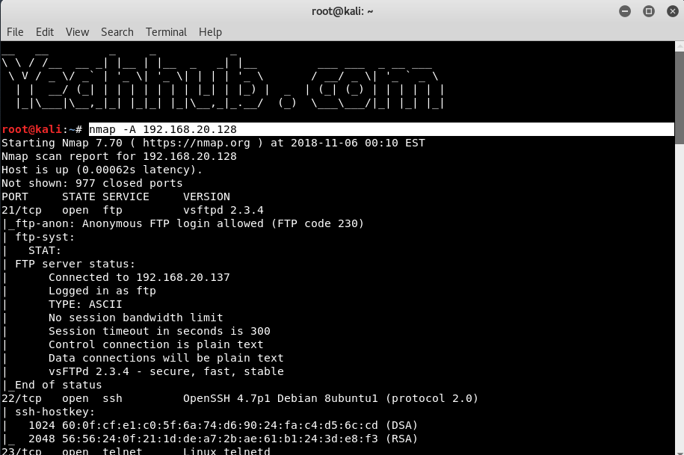

|  |  |
| --- | --- |
| Standard service detection | nmap -sV 192.168.20.128 |

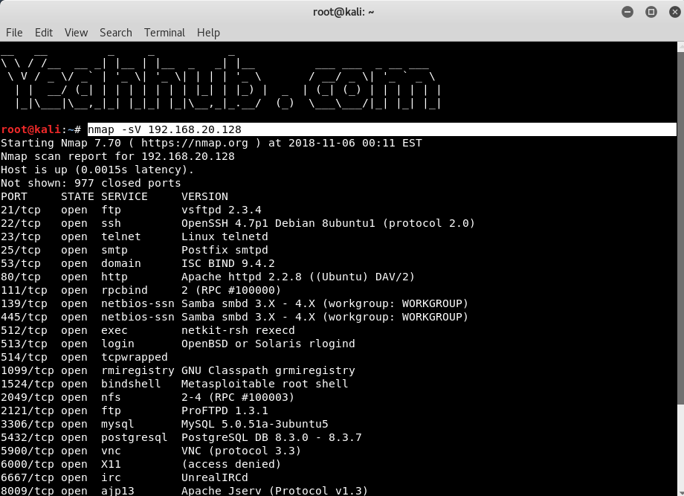

|  |  |
| --- | --- |
| Aggressive service detection | nmap -sV –version-intensity 5 192.168.20.128 |

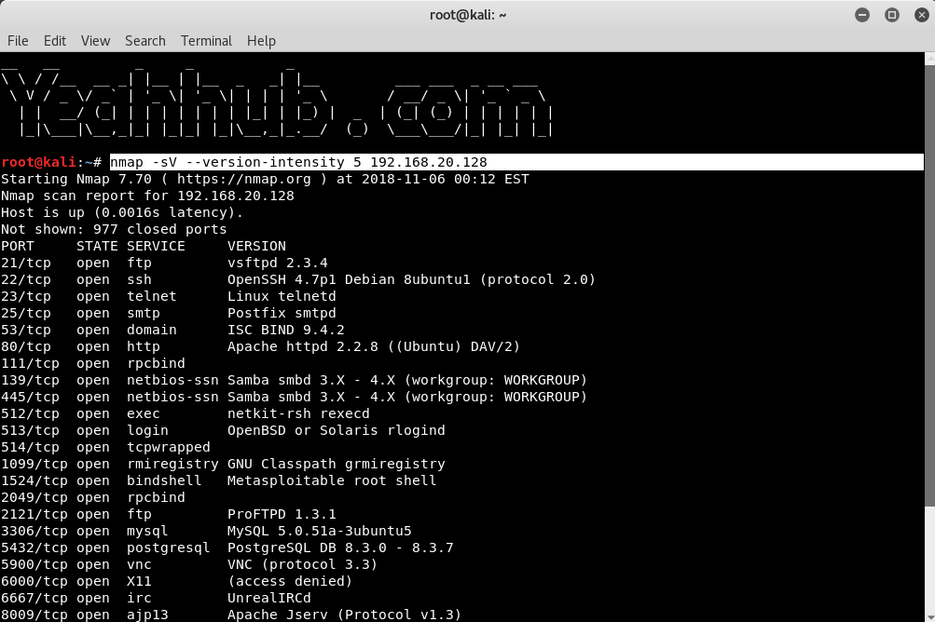

**Output Formats**

|  |  |
| --- | --- |
| Save default output to file | nmap -oN result.txt 192.168.20.128 |

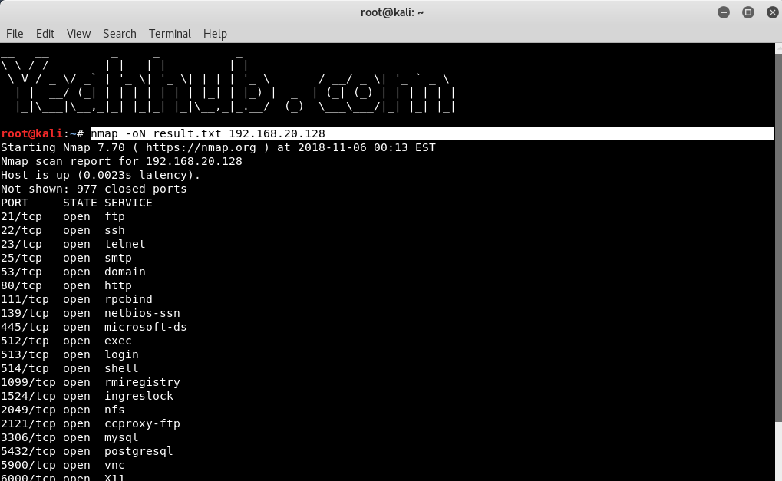

|  |  |
| --- | --- |
| Save results as XML | nmap -oX resultxml.xml 192.168.20.128 |

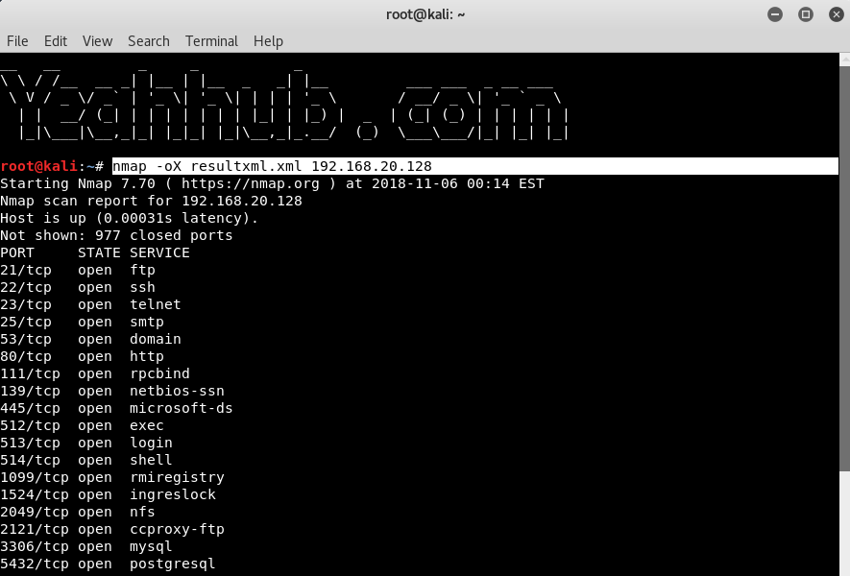

|  |  |
| --- | --- |
| Save formatted results (Grep) | nmap -oG formattable.txt 192.168.20.128 |

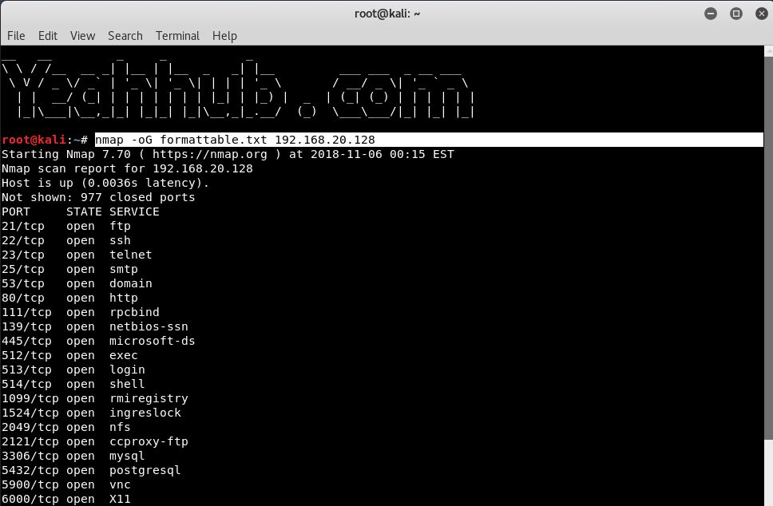

|  |  |
| --- | --- |
| Save in all formats | nmap -oA allformats 192.168.20.128 |

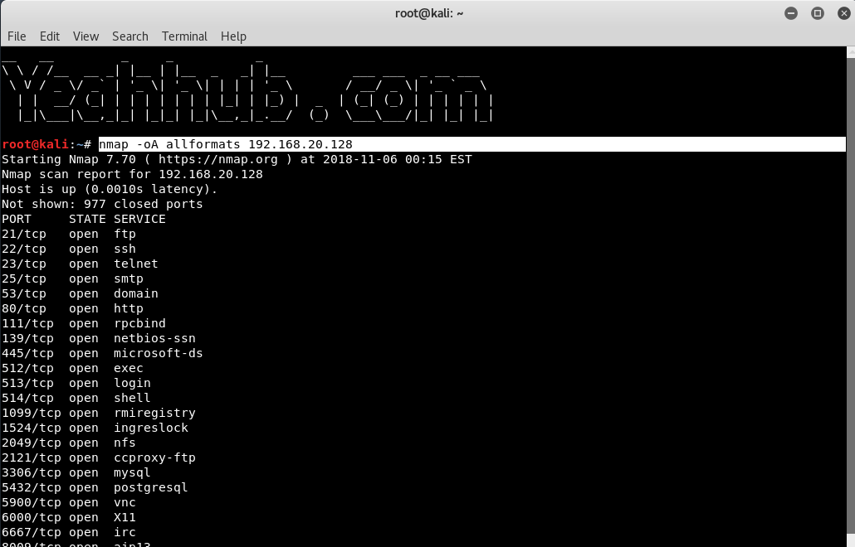

**Scripting Engine**

|  |  |
| --- | --- |
| Scan using default safe scripts | nmap -sV -sC 192.168.20.128 |



|  |  |
| --- | --- |
| Get help for a script | nmap –script-help=ssl-heartbleed |

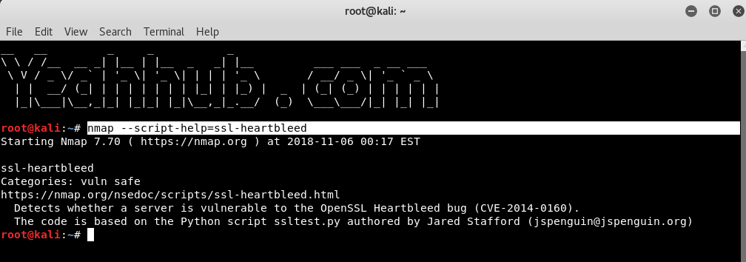

|  |  |
| --- | --- |
| Scan using a specific script | nmap -sV -p 443 -script=ssl-heartbleed 192.168.20.133 |

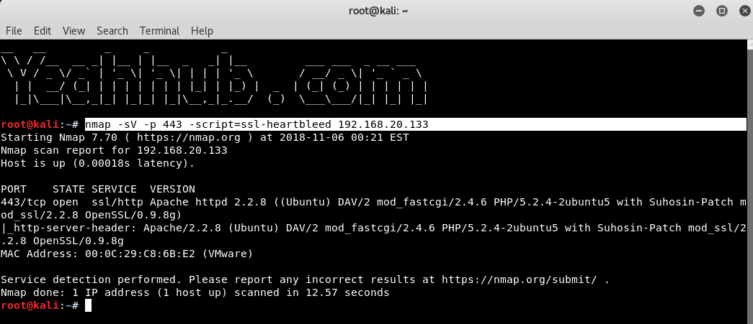

|  |  |
| --- | --- |
| Update script database | nmap –script-updatedb |

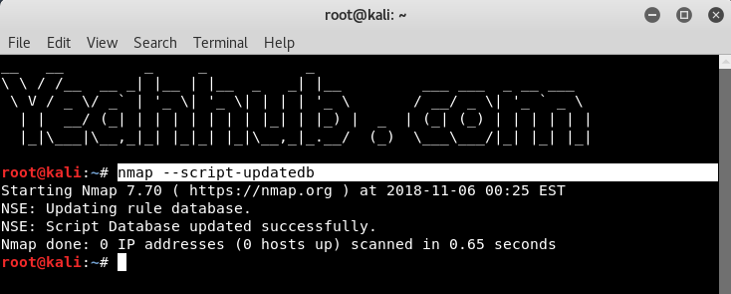

**Some Useful NSE Scripts**

|  |  |
| --- | --- |
| Scan for UDP DDOS reflectors | nmap -sU -A -PN -n -pU:19,53,123,161 -script=ntp-monlist,dns-recursion,snmp-sysdescr 192.168.20.2/24 |

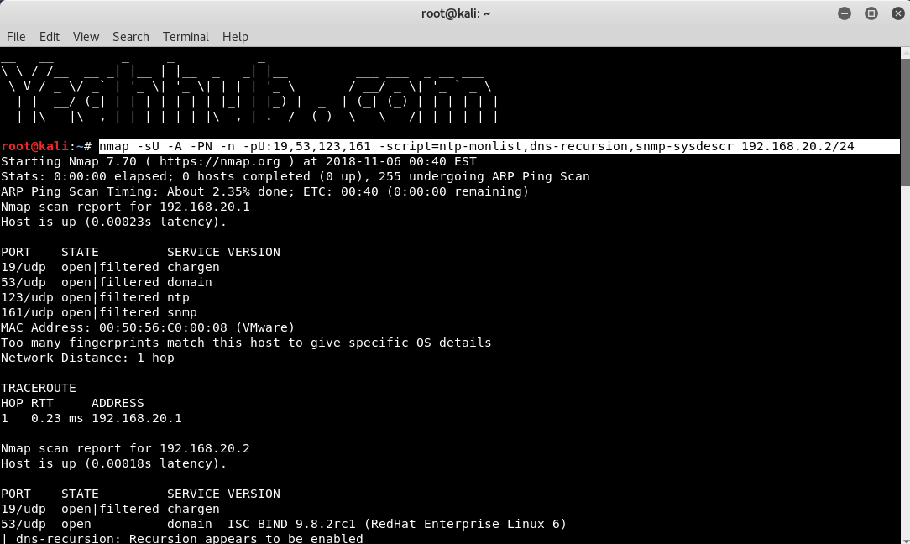

|  |  |
| --- | --- |
| Gather page titles from HTTP Servers | nmap –script=http-title 192.168.20.128 |

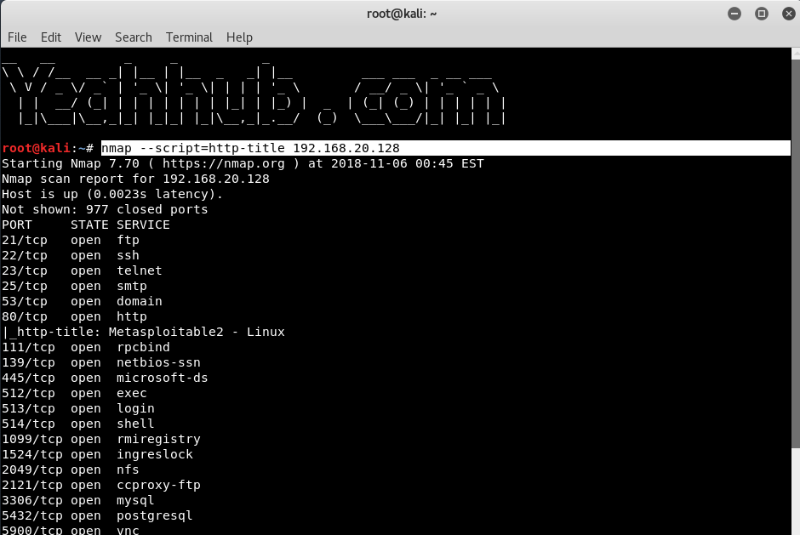

|  |  |
| --- | --- |
| Get HTTP headers of web services | nmap –script=http-headers 192.168.20.128 |

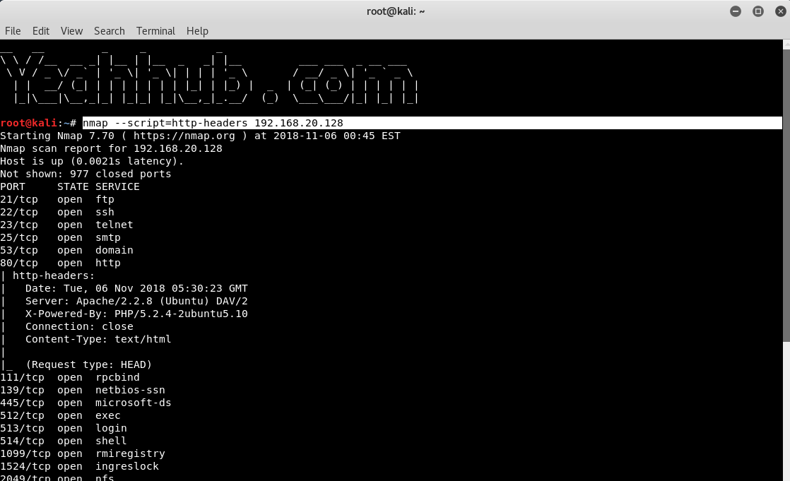

|  |  |
| --- | --- |
| Find web apps from known paths | nmap –script=http-enum 192.168.20.128 |

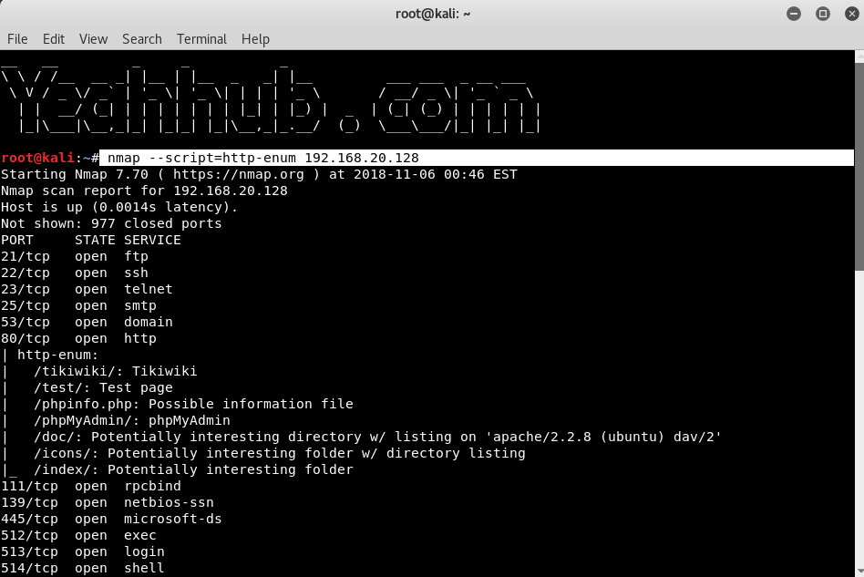

|  |  |
| --- | --- |
| Find exposed Netbios servers | nmap -sU –script nbtstat.nse -p 137 192.168.20.128 |

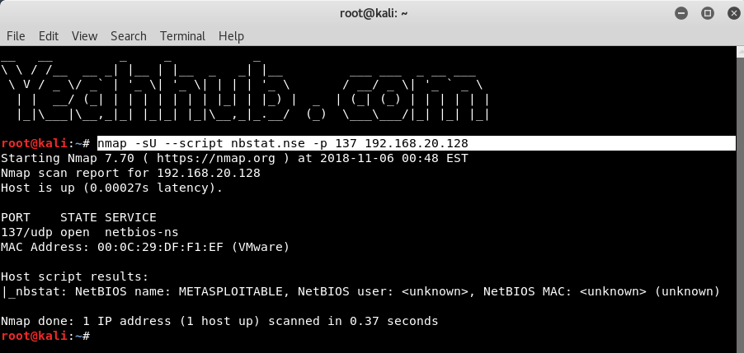

Nmap and 10 useful NSE scripts

Nmap is the most popular free security scanner developed by Gordon Lyon (f.f. Fyodor Vaskovich). The first version of Nmap a was published on October 1, 1997, in the online magazine, Phrack.

For those interested in the beginnings of this scanner, here is a full article that shows the capabilities and source code of the first version of Nmap: The Art of Port Scanning.

At the time of writing this text, the latest version of Nmap is 7.70. This version is equipped with 588 NSM scripts (Nmap Scripting Engine), which, along with a huge number of standard scanning options, give the opportunity to examine more carefully the hosts we are interested in.

NSE can be used, among others, to more accurately detect the version of a given service, break usernames and passwords, detect and use known vulnerabilities, and even detect existing back gates left by the attacker and fuzzing.

A list of all available scripts with descriptions is published at https://nmap.org/nsedoc/. Alternatively, to get a list, we can use the terminal (assuming that Nmap has been installed in the default location):

1. http-enum.nse

The http-enum script, using the default fingerprints database, sends over 2,000 queries to the web server, trying to reach files and/or directories specific to popular web applications. If the server returns the code “200 OK” or “401 Authentication Required” to any of the queries, it will mean that the desired file or directory is available on the server, and then the fingerprint script will return the name of the application.

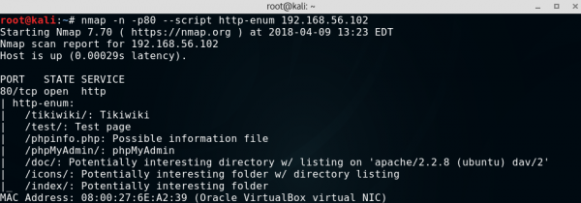

2. FTP script

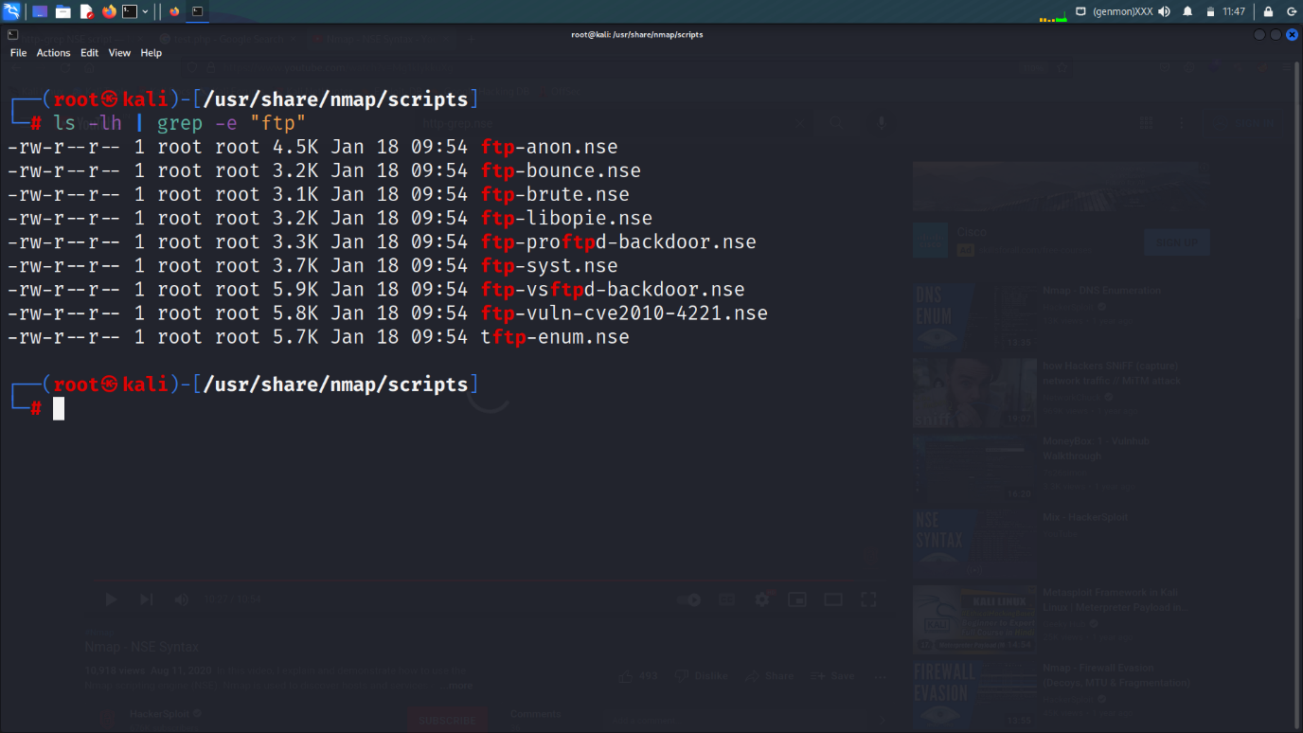

Use grep command to filter the result of the script

ls -lh | grep -e “ftp”

Here iam using the ftp script with the help of nmap

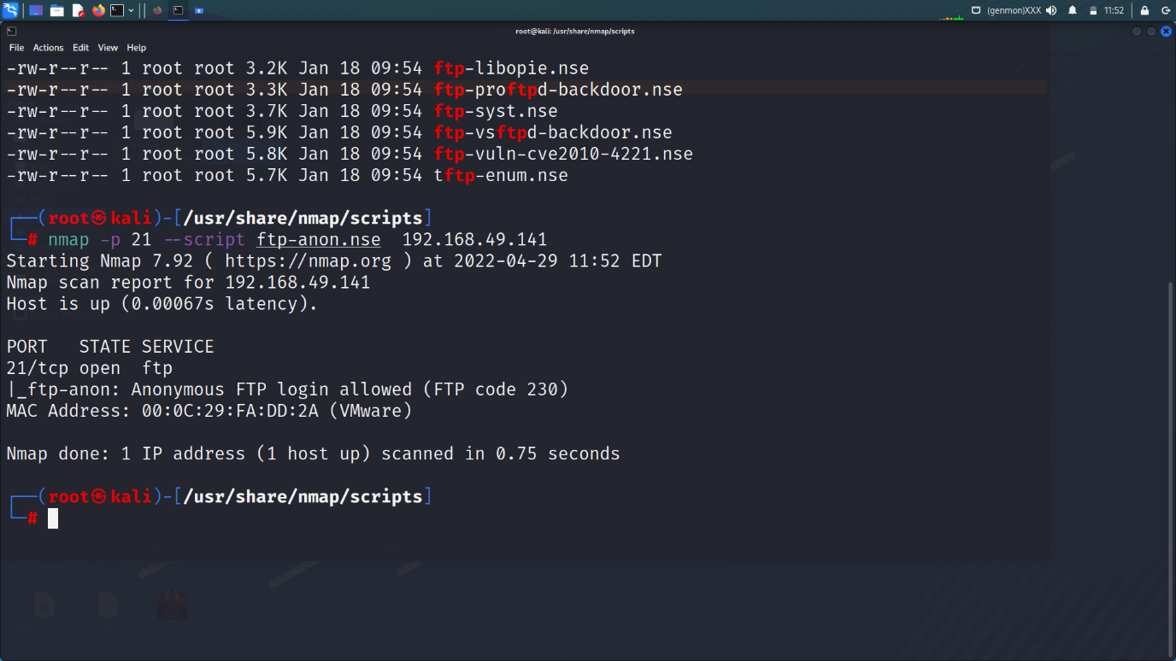

Nmap -p 21 –script ftp-anon 192.168.49.141

ftp-anon (script) login access

A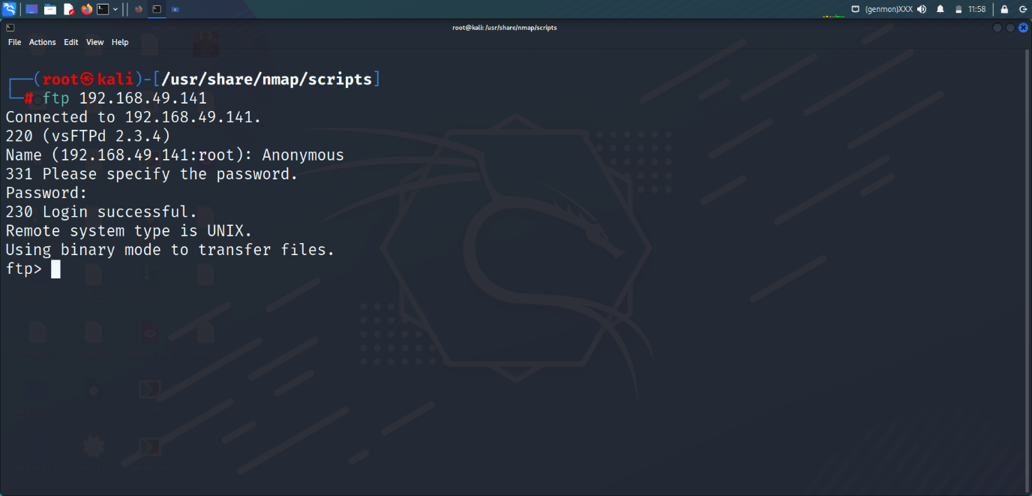

Password :- Anonymous

3.Exploit Backdoor with the help Nmap

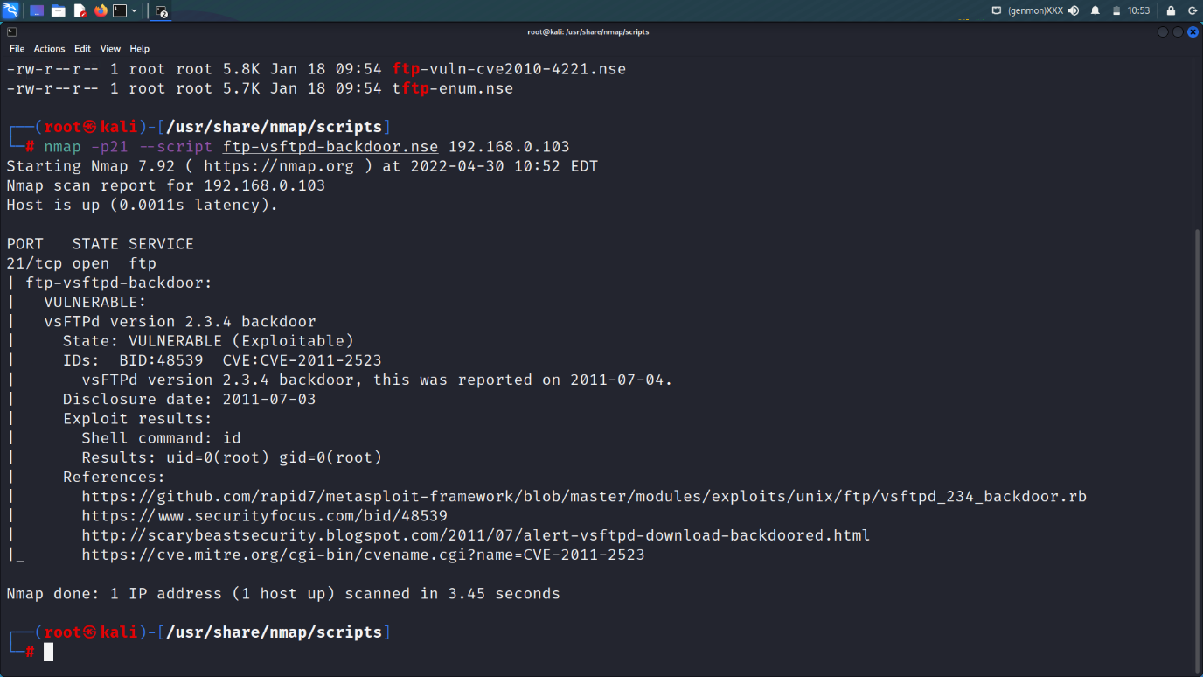

Here we clearly see that this version of nmap is exploitable. Here we are using the script of ftp “ftp-vsftpd-backdoor.nse” for exploiting the version of ftp.

CVE: CVE=2011-2523 (cve infotmation)

References:

https://github.com/rapid7/metasploit-framework/blob/master/modules/exploits/unix/ftp/vsftpd_234_backdoor.rb

| https://www.securityfocus.com/bid/48539

| http://scarybeastsecurity.blogspot.com/2011/07/alert-vsftpd-download-backdoored.html

|_ <https://cve.mitre.org/cgi-bin/cvename.cgi?name=CVE-2011-2523>

Results: uid=0(root) gid=0(root)

vsFTPd version 2.3.4 backdoor, this was reported on 2011-07-04.

vsFTPd version 2.3.4 backdoor

nmap -p21 --script ftp-vsftpd-backdoor.nse 192.168.0.103 (nmap command)

4. exploit telnet with the help of nmap script

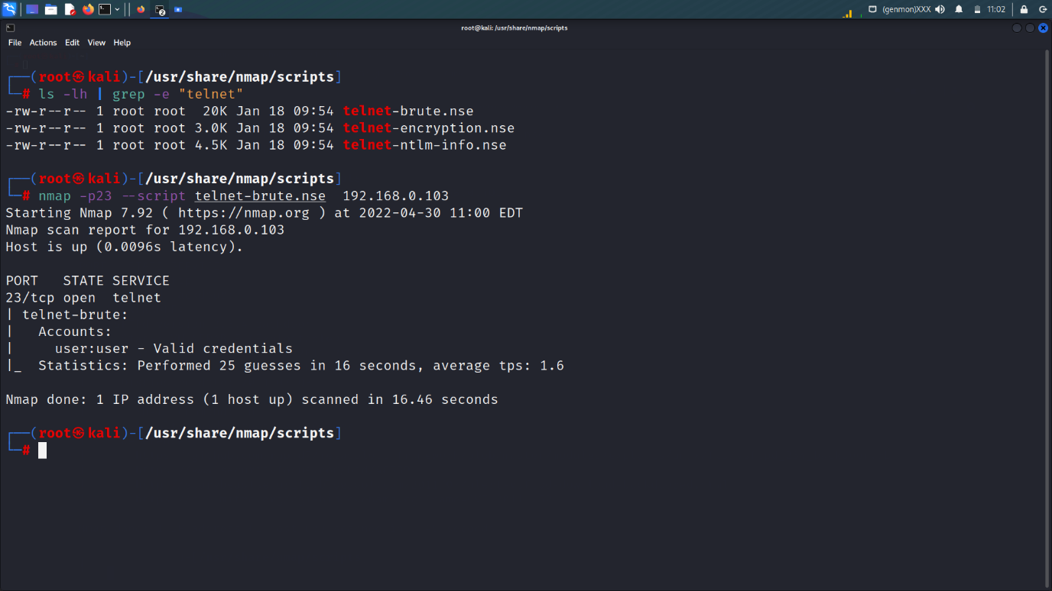

Here we clearly see the we found the username and password telnet

Username :- user

Password :- user

nmap -p23 --script telnet-brute.nse 192.168.0.103

lets login it with the help of telnet port

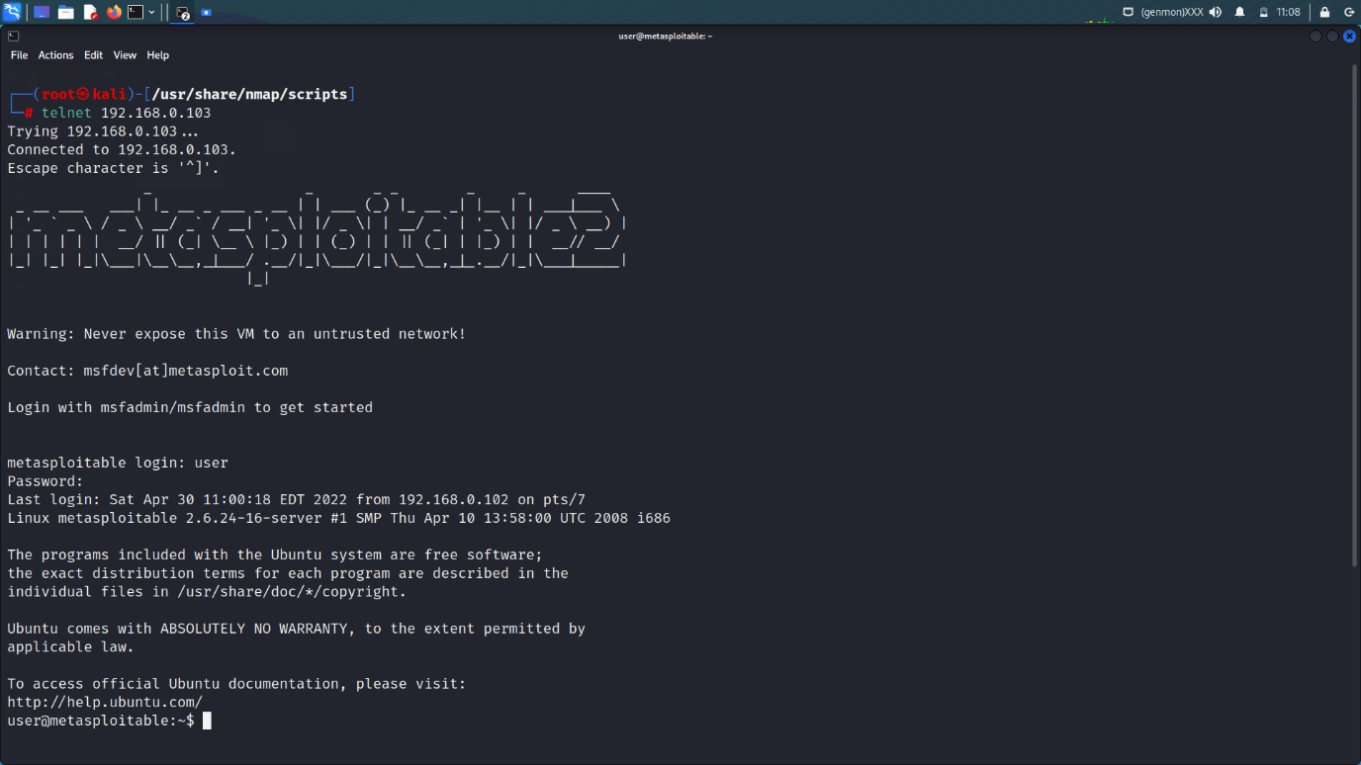

telnet 192.168.0.103

6.ssh-brute.nse

The ssh-brute script is used to break SSH service passwords with predictive text input. By default, it uses its own database, rather an extensive database of users and passwords. However, you can pass our letters to the script using the userdb and passdb arguments.

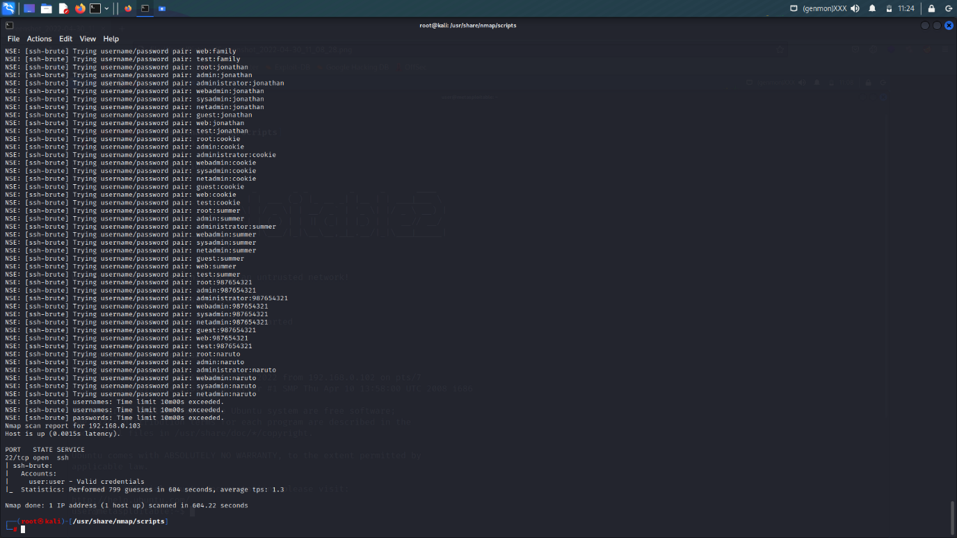

Username:- user

Password:- user

4. dns-brute.nse

The dns-brute script tries to find as many subdomains as the host is being tested using the most frequently used subdomain names.

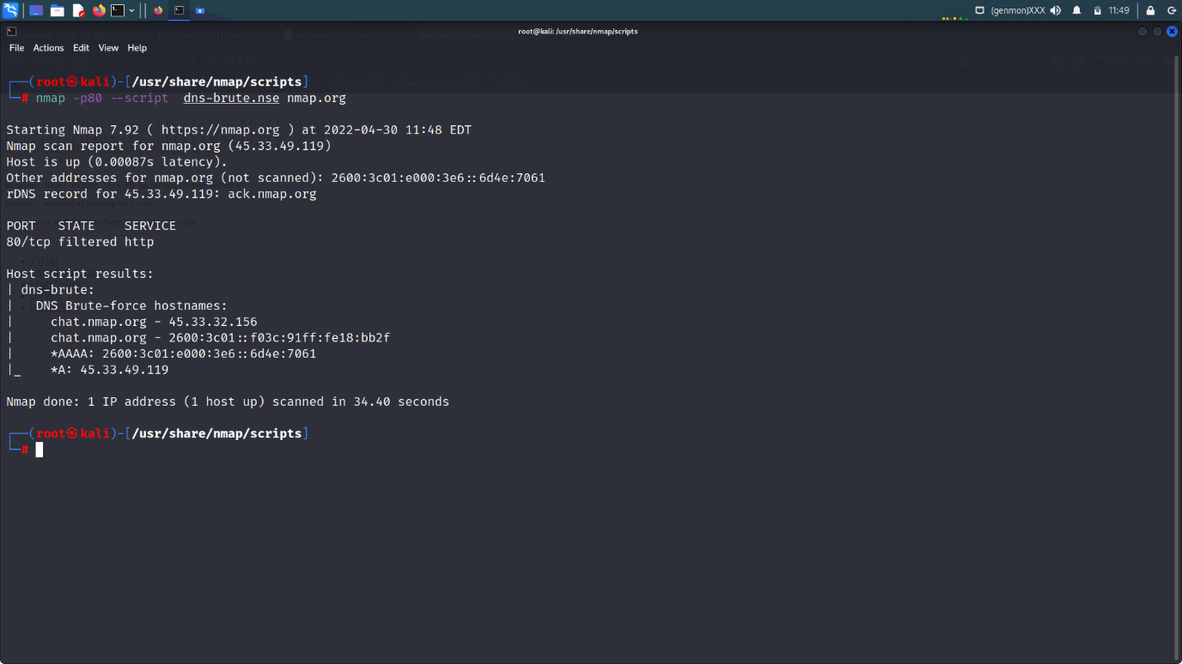

7. http-config-backup.nse

The http-config-backup script sends many queries to the web server, trying to get a copy of the configuration of popular CMS left behind by the user or text editor. According to the research conducted by the author of the CMSploit tool, which is inspired by the http-config-backup script, almost 1% of websites using CMS reveal their access data to the database through left copies of the configuration.

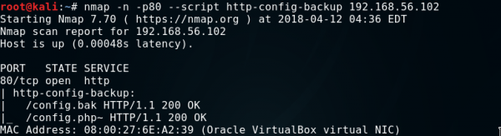

Figure 10. The result of the http-config-backup script and two copies of the configuration found.

8. vulscan.nse

The vulscan script adds Nmap’s vulnerability scanner functionality. Unfortunately, it is not part of the standard Nmap script library, so to use it, please download it from http://www.computec.ch/projekte/vulscan/?s=download and place the unpacked vulscan folder in the Nmap scripts directory.

In case of this script, you must use the additional option -sV, which is used to detect the version of the scanned software, and then, on its basis, the script using several databases (.csv files in the vulscan folder) suggests possible vulnerabilities.

9. mysql-empty-password.nse

The mysql-empty-password script checks whether it is possible to log in to the MySQL server to the root or anonymous account using an empty password.

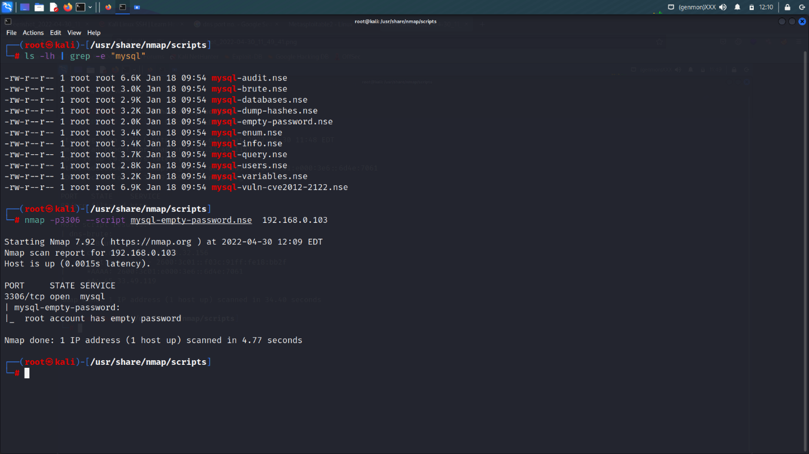

10. mysql-users.nse

The mysql-users script is used to list the users available on the MySQL server. To list, we will use the root account with an empty password, which we discovered in the previous script. We provide access data in the mysqluser and mysqlpass arguments. When the password is empty, you can omit the mysqlpass argument

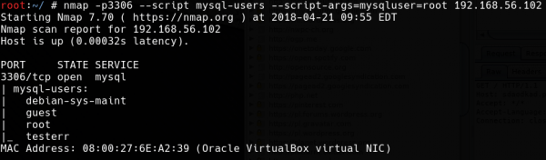

## ****Summary****

Nmap should undoubtedly be one of the basic tools of every pen tester and administrator, and the ever-growing number of extensive NSE scripts makes it having the features that allow detailed testing of network security without the need to use other tools.

Advanced Angry IP Scanner

Advanced IP Scanner is fast and free software for network scanning. It will allow you to quickly detect all network computers and obtain access to them. With a single click, you can turn a remote PC on and off, connect to it via Radmin, and much more.

Downloads Links :- <https://www.advanced-ip-scanner.com/>

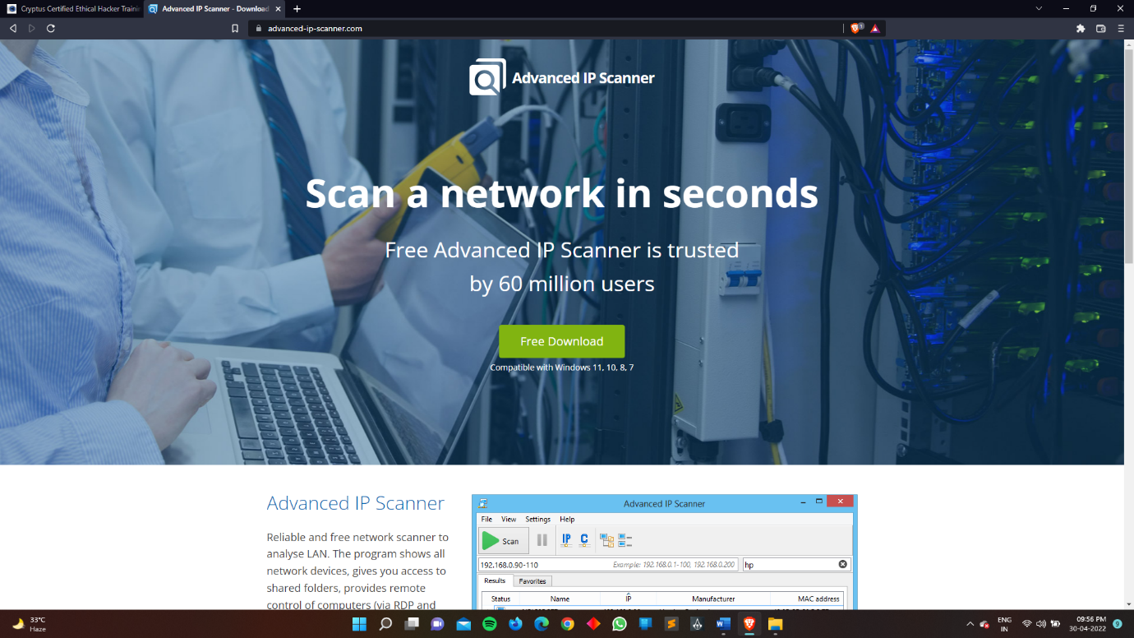

Downloads Tool from here “Advanced IP Scanner”

Working of Advanced IP Scanner :-

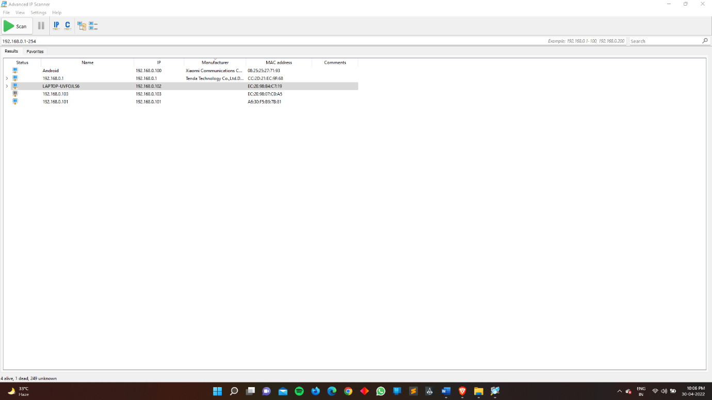

Set the target range to scan the ip address of your router

4 devices are connected to my router

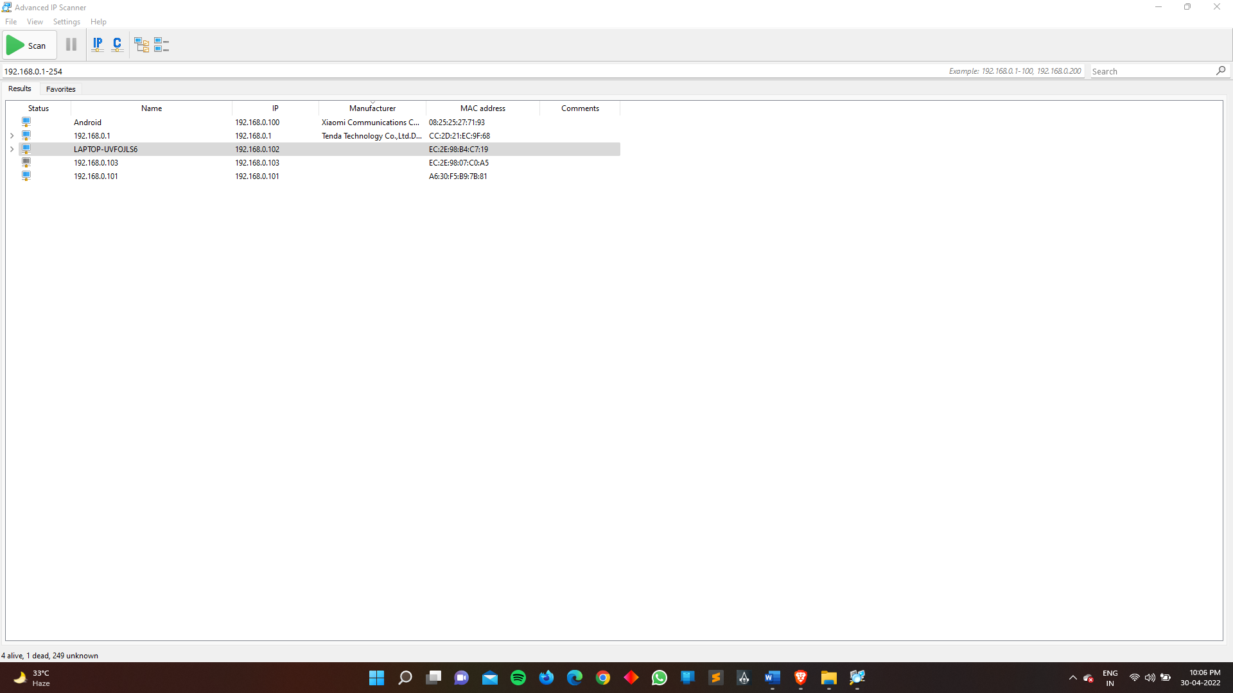

192.168.0.1 is my router ip address

Its also show the mac address of the device which is connected with the router.

Net Discovery Tool

Netdiscover can also be used to inspect your network ARP traffic, or find network addresses using auto scan mode, which will scan for common local networks. Netdiscover uses the OUI table to show the vendor of the each MAC address discovered and is very useful for security checks or in pentests.

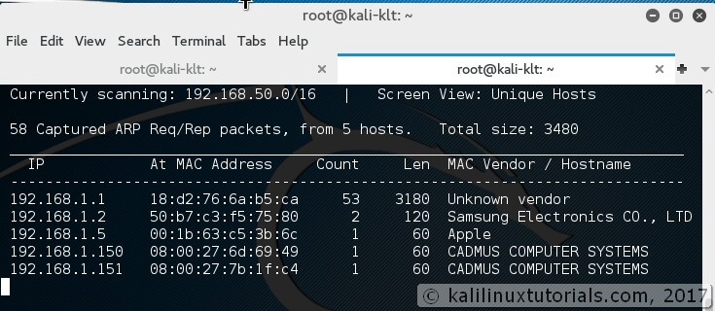

### **Features:**

1. Simple Arp Scanner
2. Works in both Active & Passive modes
3. Produces a live display of identified hosts
4. Able to scan multiple subnets
5. Timing Options

### **Options:**

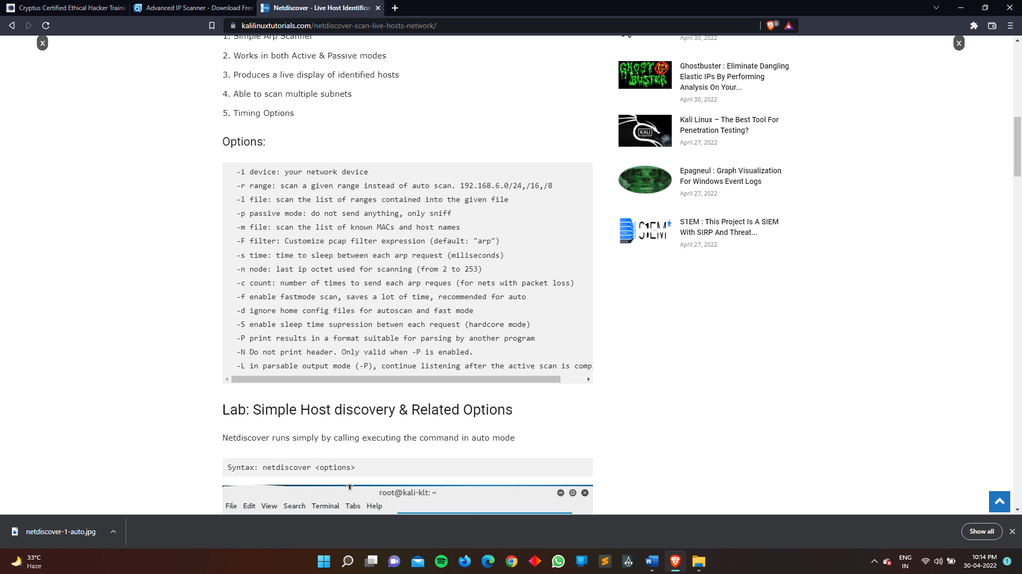

## Lab: Simple Host discovery & Related Options

Netdiscover runs simply by calling executing the command in auto mode

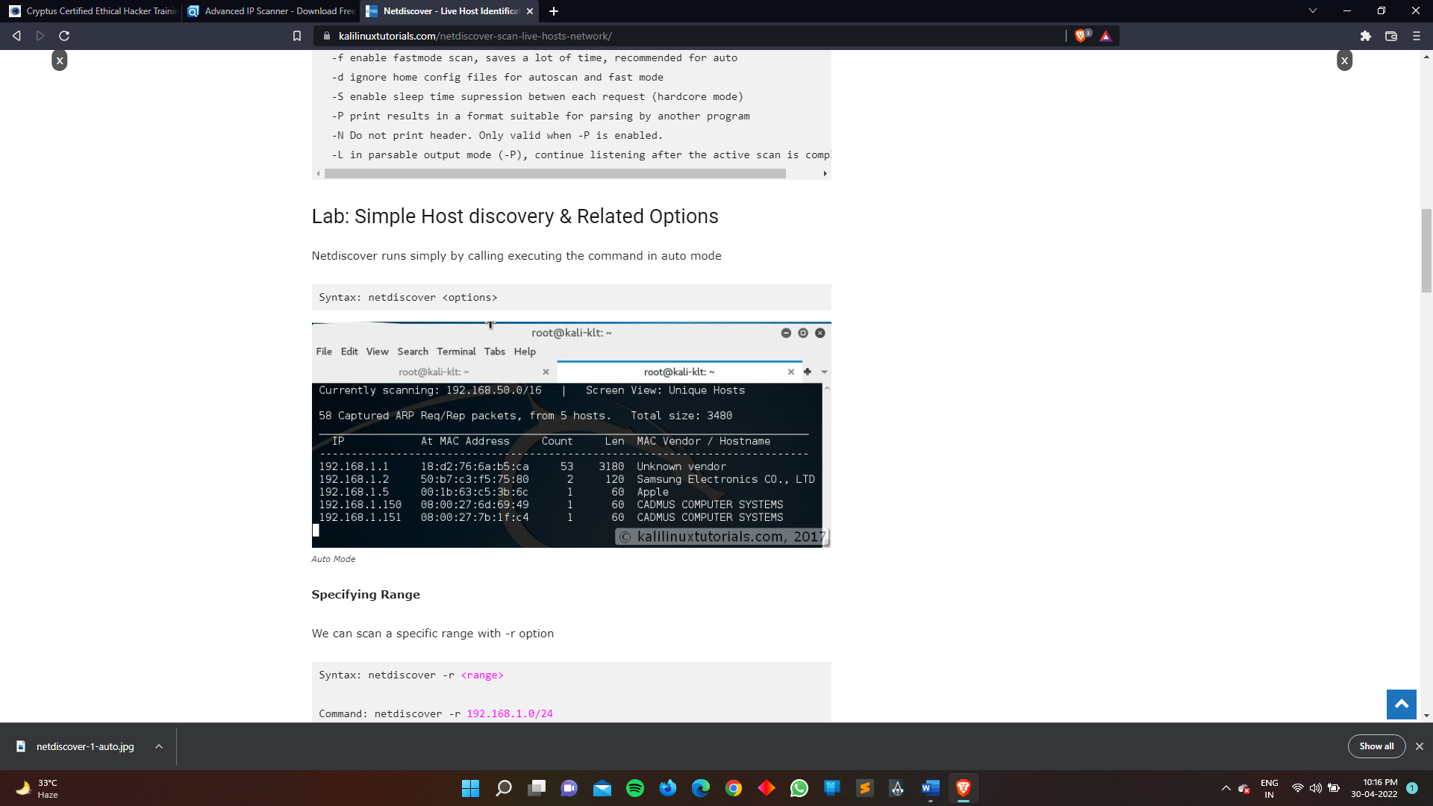

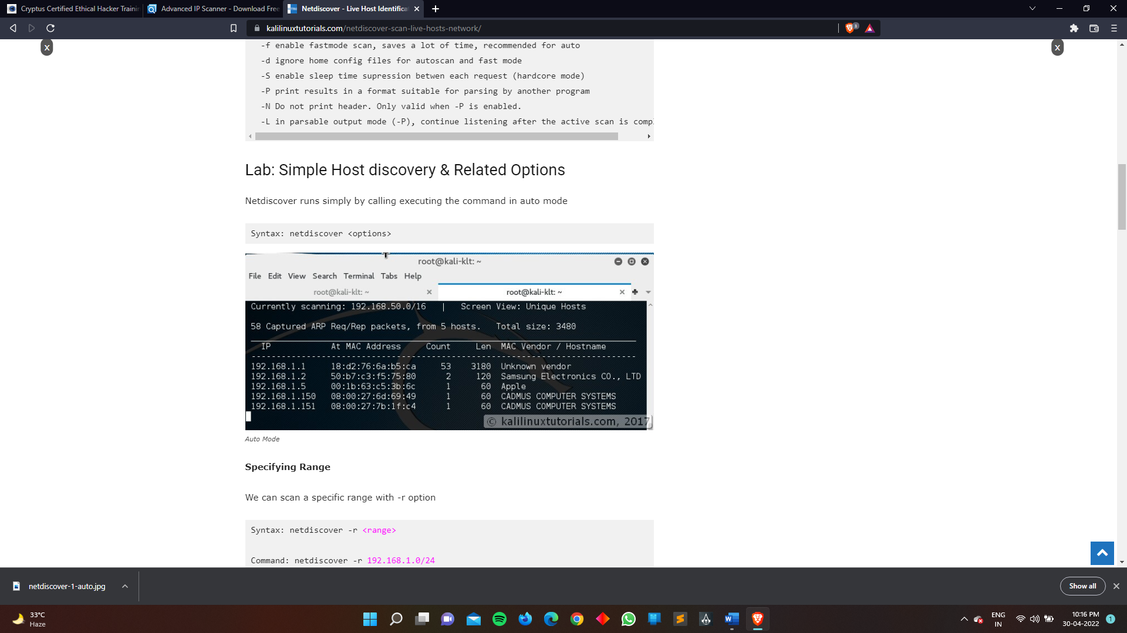

**Specifying Range**

We can scan a specific range with -r option

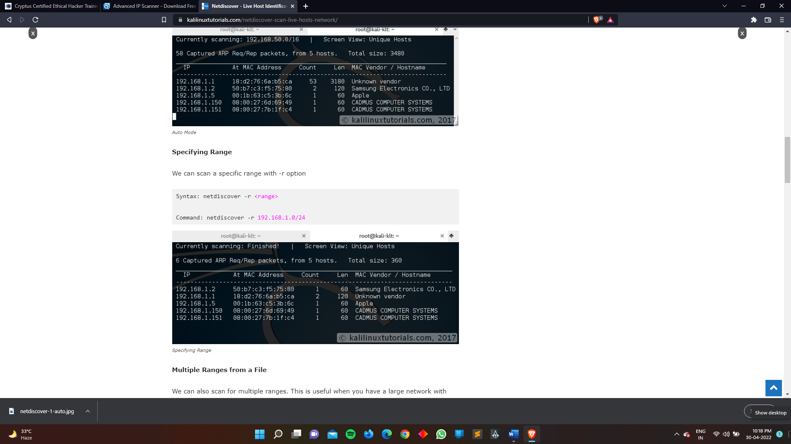

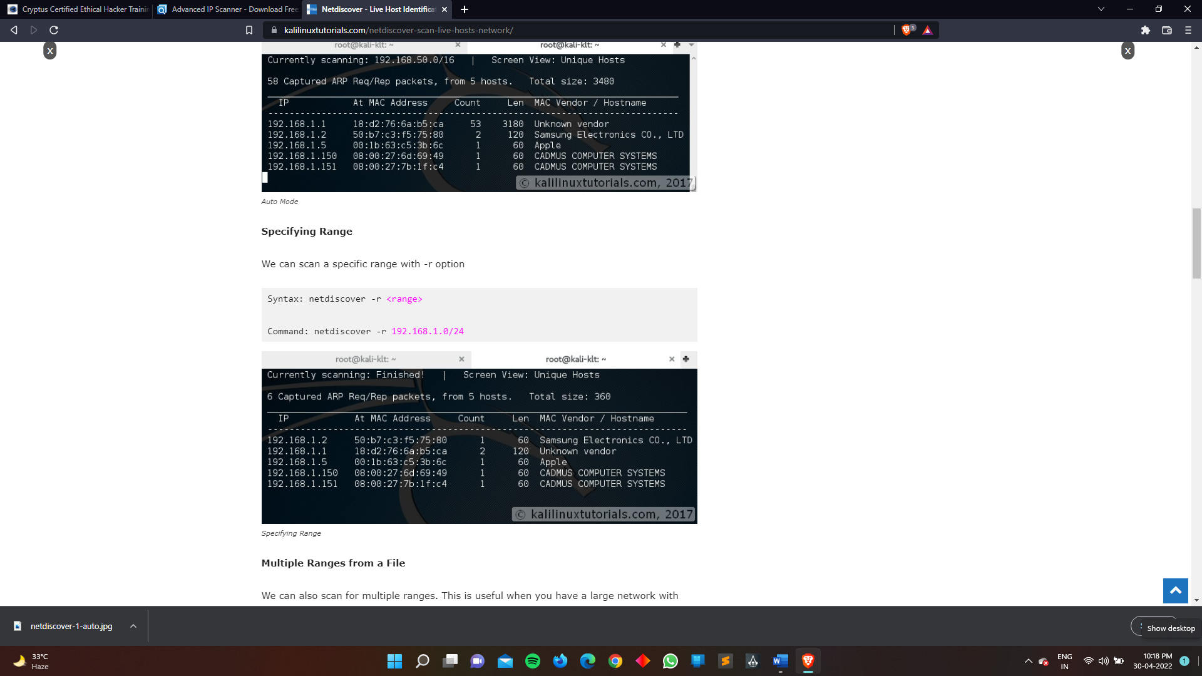

**Multiple Ranges from a File**

We can also scan for multiple ranges. This is useful when you have a large network with multiple subnets & networks. For this, simply we need specify all the ranges we want to scan in a file line-by-line

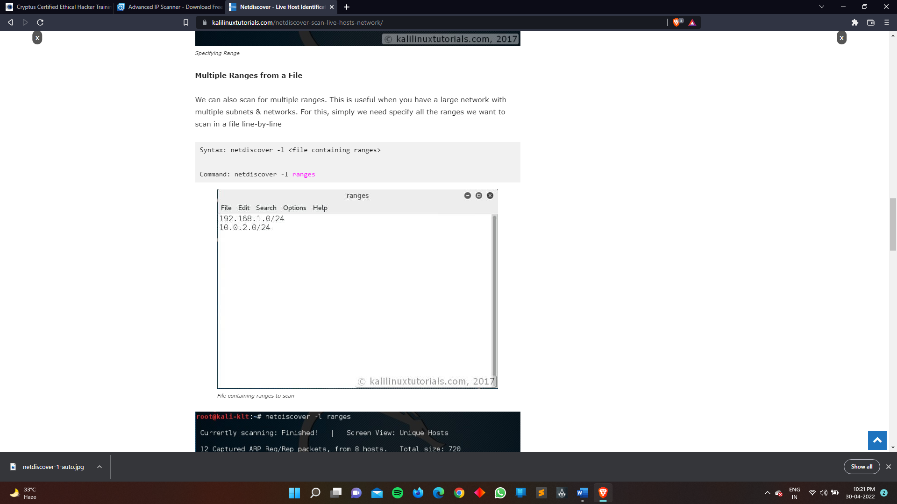

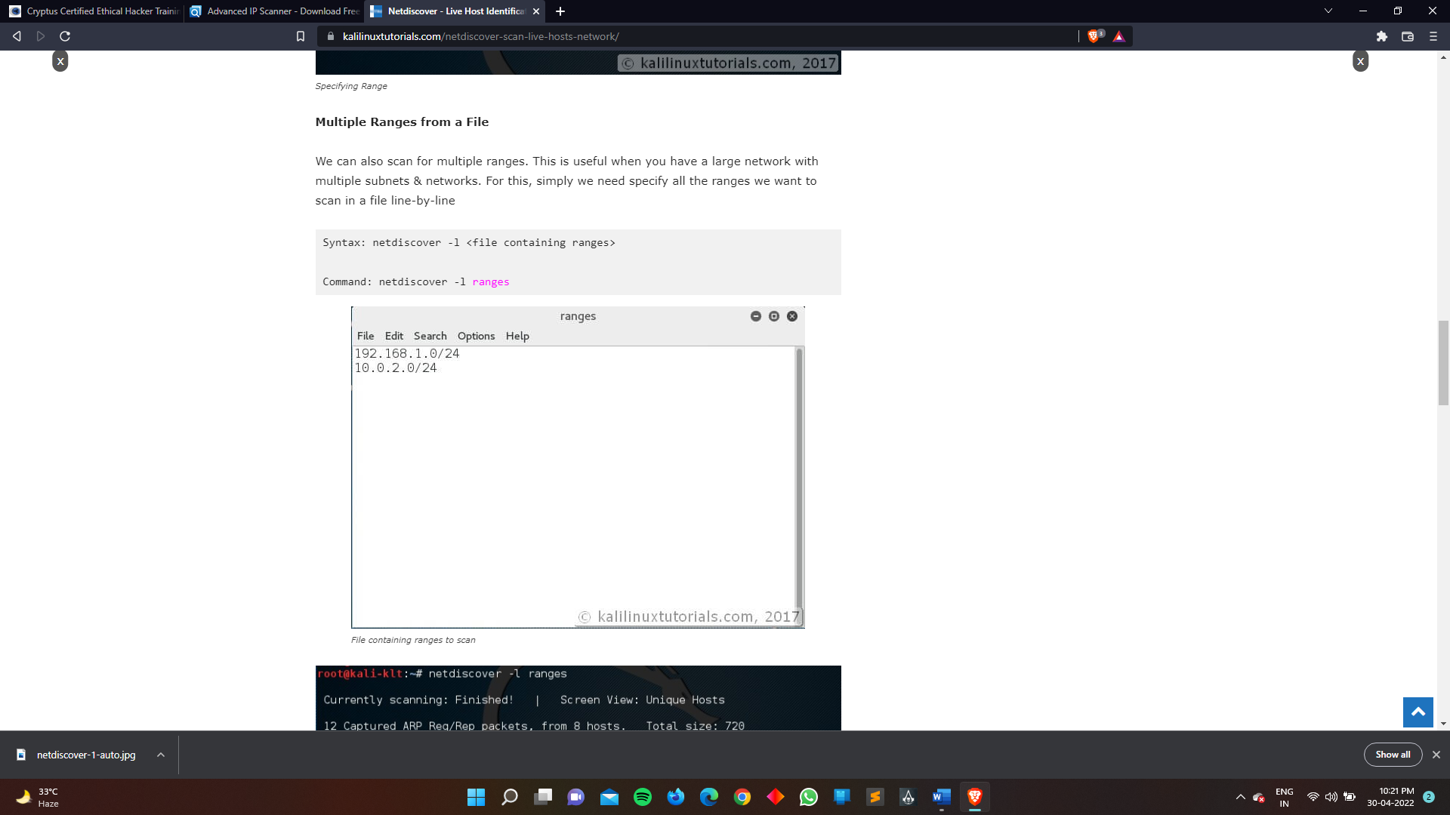

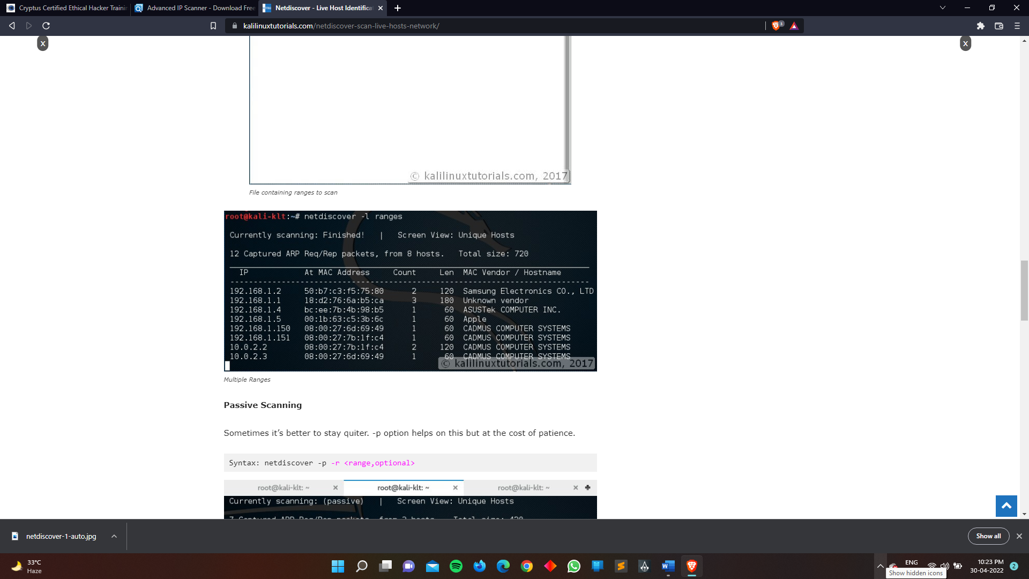

## Conclusion

Netdiscover is a simple arp scanner which can be used to enumerate hosts. I would like to share with you one of my experience. Out of curiosity, I tried running the tool  in my company network. The network has a firewall & I am part of the monitoring team which needs to look for network traffic anomalies. So me & my team can get the info even if somebody is performing a ping between internal hosts. We have detected ping scans, web server scans with nikto etc from our internal network. So I had a clear idea about my target network. So I ran the tool in passive mode. It ran for about 7 hours & I got more than 100 IPs. I cross-checked this result with my monitoring tool and the numbers were about the same. But interestingly not even a single alert was generated from the monitoring tool. I also wondered why it didn’t detect that my interface was in promiscuous mode. So I got 2 major results out of this. One is that I got all the IPs in the network which were live over a period of time. The second is that my monitoring tool was not capable or was not configured to detect promiscuous interfaces in the network. So here are my suggestions.

1. Never perform a scanning activity without having a clear knowledge of your network.
2. As the Kali Linux slogan says “The quieter you are, the more you are able to hear”
3. Use the results from such activities in a constructive way

So if you learned something new from this tutorial, please support me by sharing it with those whom this will benefit.